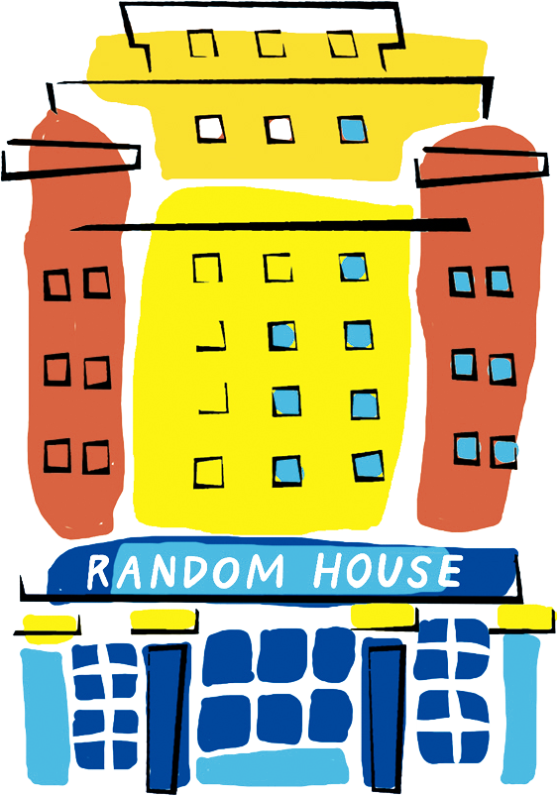
Random House Group

Presents

A Study In Herds: The Notebooks Of Dr. Oscar Antinous Alexander Benjamin Parlay

As part of the Random House Group's continuing commitment to digitising its historical collection of documents, we are proud to present a preview of the field journals, writings and ephemera of Dr. Oscar Parley, to be published in full late in 2013.

These are facsimile scans of three selected pages from the diary and everyday book of noted anthropologist and traveller Oscar Parlay, a man famous for his discoveries and studies in the fields of ethnodentology, ethnolinguistics, and cultural relativism. Today is the twenty-year anniversary of Parlay's death, and to coincide with talks being given at the Wellcome Trust and Hunterian Museum in London, Random House is proud to release this rare, first-hand glimpse into the mind of a man at once brilliant and troubled, whose opinions distanced him from the emerging liberal schools in immigrant America of the late 1920s and 1930s, and who died with many of his ideas discredited, despite their extraordinary influence upon the field of anthropology.
These three pages of notes, designed to showcase Parlay’s idiosyncratic style, were written in 1925, a year in which Parlay travelled extensively in the Indian Ocean, Southern Russia, and the Middle East, conducting dental cataloguing and more general writings about the nature of man and his place in the world.
Please check the Random House website for news of more of Parlay’s writings, currently being digitised by a Random House partnership program.

